Jessica Bryson Consulting

Overview:
A non-profit organization of Mississippi County wants to receive financial assistance from Center Learning Center grant. Getting this grant will help L3 After School Program provide a learning center for students in need of extra help with their school lessons. The students will range from elementary to middle school students. The primary goal is to enhance their academic achievement, social development and provide literacy skills for at-risk students. This organization is for students who attend MS County Middle School in the MS.
Objectives:
Improve the students’ understanding of the subject.
Master all objectives in the lesson
Key Questions:
How many subjects was available?
How many hours a day after school?
How to motivate students and keep them motivated?
How were students be tested?
Justification for Evaluation:
The evaluation was provided to see if the methods taken helped the students. It also allowed the stakeholder to share their reviews and insight on the program. The completed evaluation allowed the instructional designer to know and understand their areas of improvement.

Evaluation Matrix for L3 After School Program
Objective | Stakeholder | Data Collections | When | Purpose
A) Documented how in-depth the lesson will be | Instructor, student, instructional designer | Interview | August | Formative
B) Documented how successful the lessons were | Student, instructor, instructional designer | Assessment | August-May  weekly | Summative
C) Documented student’s performance after lesson is complete | Student | Assessment | August-May  weekly | Summative
D) Documented how students felt about the lessons, activities, and methods of instructing | Student, teacher | Survey | May | Summative
E) Documented teacher perception of program | Instructional designer, instructor | Survey | May | Summative
F) Documented parent perception of program | Parent | Survey | May | Summative
G) Documented the outcome of student learning, their abilities, and study habits | Student | Survey | May | Summative

Evaluation Model:
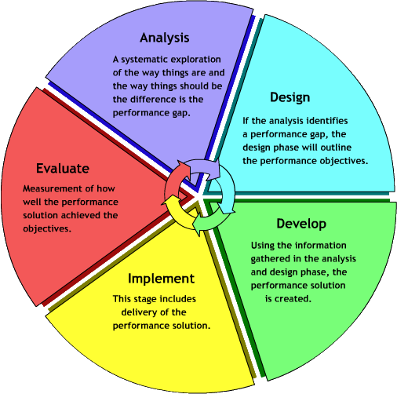
This model was chosen because no matter what lesson is designed it gives room for improvement. The process is the same and will catch any of the areas of improvement needed once implemented.
Evaluation Process:
The first assessment was given to the instructor before the program even starts. The instructor went go over the objectives and the material and then had an interview with the instructional designer to discuss teaching methods and any errors found in the lesson. At the end of the program evaluations were given to the instructor, students, and the parents. This was so the evaluator will get direct insight of the program and how it helped the stakeholders. Assessments were given to students weekly to track their progress.

Time:
Pre-evaluation: August before program starts
Assessments: Weekly
Final evaluation: May before end of program
Budget: $6050.00 annually for this program
Qualifications:
The evaluator had to have a master’s degree in Instructional Design. Also, had prior experience in similar programs and experience in conducting the same type of evaluation described in the evaluation plan. In addition to prior experience the evaluator had to be proficient in Microsoft Word, Excel, and PowerPoint. Along with computer skills the evaluator had to have strong project management skills; demonstrated ability to develop and manage multiple projects at once, strategize timelines, and meet deadlines. The evaluator also had to have excellent oral communication and presentation skills.

Findings from the L3 After School Program Survey
This section provides an analysis of the data collected from three surveys administered among L3 stakeholders who participated in the program in 2015 through 2016. The first survey targeted the students and their academic growth as the program ended. The second survey targeted the parents’ feedback of the program. And the last survey targeted the teacher feedback of the impact the program had on the students. There were eleven programs provided: anti-bullying, character education, reading essentials, entrepreneurship, personal finance, arts & crafts, music class, homework tutoring, outside recess, learning math with iPad, and career development prep. The main areas were math and literacy. Programs were offered on a request basis and had to have at least at three students to sign up. Grade levels were 6th-8th. There were thirty-five students in the program, five teachers, and five community volunteers. The after-school program was Monday-Wednesday from 3:30pm-6:00pm. The books for the program was donated by the local library. Transportation was also provided for the students by the school district.
Figure 1. Student’s academic growth. Students were give pre-and post assessments to show the academic growth at the end of the program.
Figure 2. Represents the parents’ feedback after the L3 program was complete. 40% of the parents had a positive reaction to L3s productivity while 20% of parents had a negative reaction. However, 40% of the parents did not return their surveys.

Figure 3. represents the teachers’ feedback. The teachers felt L3 had a positive impact on students in all grade levels.

Contact:
Jessica Bryson Consulting
662-222-3456
Jlb1076@msstate.edu

