3Audio | Video | Notes
Welcome to How to Develop a Portfolio  By Jessica Bryson |  | Soft music playing
*Attention Getter*  Think about your dream job. Now write down a fun fact about it. Ask yourself what skills do you already have that relates to your fun fact. Pause the video if needed | 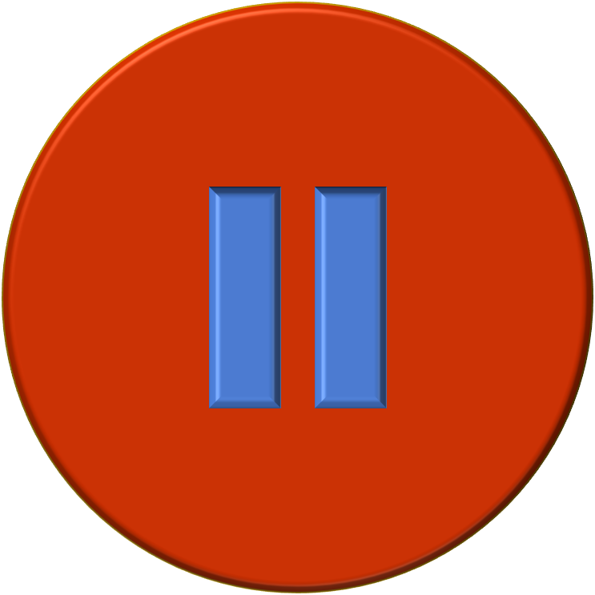 | Soft music playing while learner think. Pause appears along with statement
In this course, you will learn how to create a resume and an online job portfolio. | 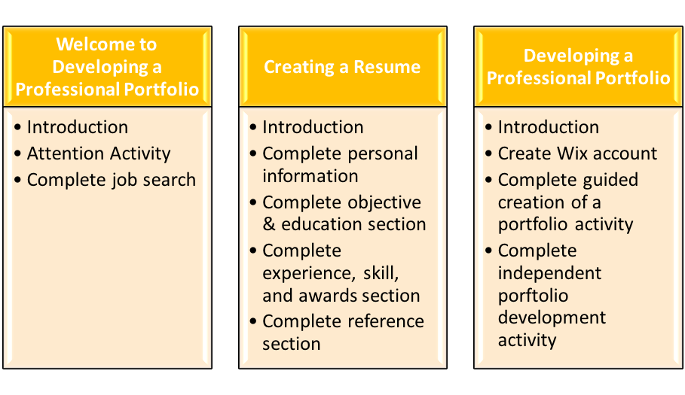
You will need to go ahead and download the documents needed to complete the practice activities. Instructions can be found on blackboard within the instructions page and activity 1 folder.
We are now about to begin the resume section. Here is what will be covered in this section. Take a minute to review it.
You will need to upload the sample resume. The resume is uploaded in your practice activity folder. |  | Using this resume to make corrections.
Have you ever created a resume? If so hearing the word resume should not be a surprise. If you have never created a resume; a resume is a formal document that displays the applicant’s objective, work experience, education and skills, and any other activities or special awards. |  | Resumes are used to show applicants qualifications and skills for any applied position. For example, applying for an intern you may need a resume.
Today we are going to look at some resumes. One resume will be an example of good and the other will be a bad example. Later you will have the opportunity to create your own.

On this screen, you will see an example of a completed resume. Your resume does not have to be exactly like this one but it does need to follow the format. Now let’s get started.
Let’s switch over and look the completed sample resume you downloaded. At the top of this resume you should see the applicant’s personal information. Personal information should include: your current or mailing address, phone number, and email address. When it comes to formatting, we are going to center our person information to attract attention to your name and information. Name should be bold and around 12-14pt. |  | Add callouts to reassure name and categories be bold and around 12-14pt font.
Here we are going to look at the objective for this resume. The objective is your goal or goals and intentions for the position you are applying for. Your objective can be between 2-3 short sentences. |  | Zoom in on objective
The next sections we are going to review are the education and work experience. Education and work experience should be formatted in chronological order from present to past.
The education section should have the degree you are seeking with concentration, university, designated graduation date. Your GPA is optional.
The work experience section should include job title, your position, date started, and date ended (if you are not currently employed there). List what duties were completed or performed at the job. When describing the duty use the correct form of a verb. Use your reference booklet for examples of verbs. The descriptions should be in bulletin point.
Now we are going to look at completing the skills, activities/awards sections. The skills section requires a list of all your acquired skills. For example, if you have experience in Microsoft Office it will be listed under your skills section. Activities can be anything you are a part of such as organizations. On the reference section, it is always best to list “available on request”
Look at your download example of a bad resume. Take the time out to make corrections to your bad resume according to the information learned. Now that we know how to complete a resume; Pause the video and create your own personal resume. The directions are found in the assignments tab. You can always look back at the good sample resume or use your reference booklet.

Creating an online portfolio.  Now since you have completed your resume…Lets move on to creating an online portfolio. | 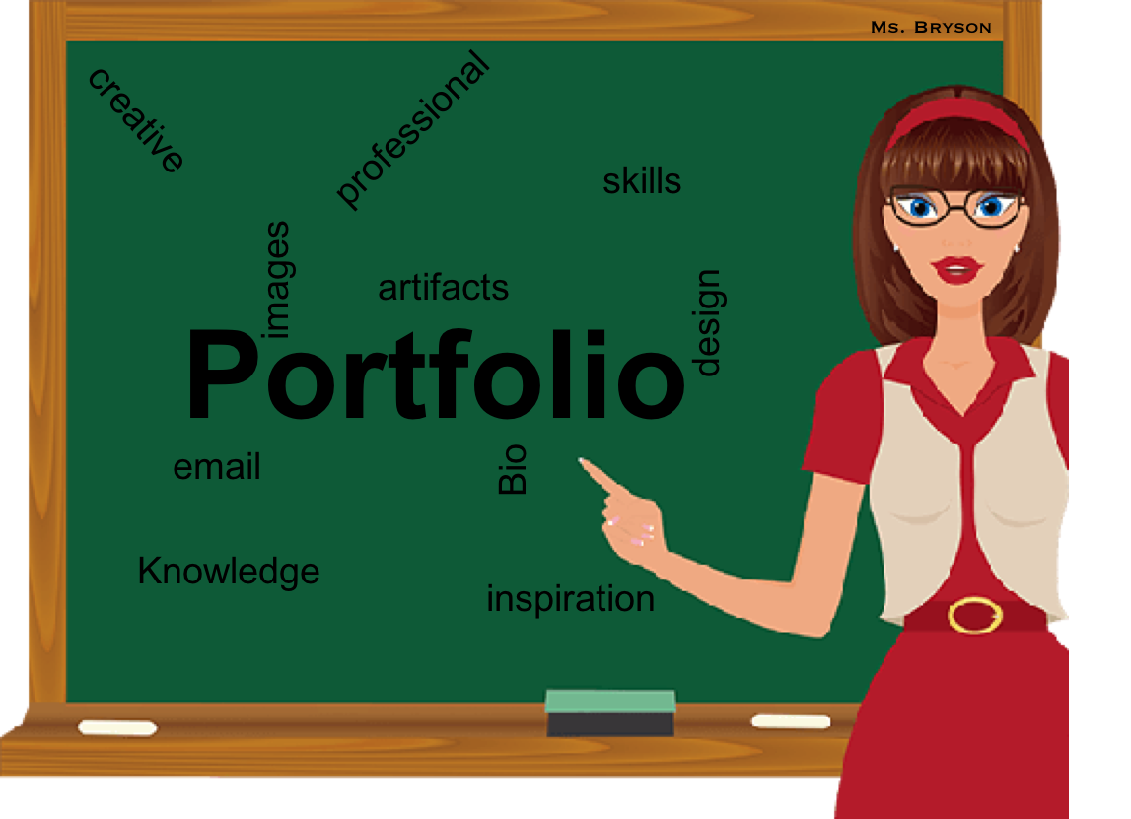
This graphic on the screen is an overview of this lesson. Take a minute to review it. |  | Fading soft music
We are going to create a portfolio using Wix online. First you must sign up. You can sign up by creating an account or using a gmail email address. Let’s take a minute to sign up. Pause this video until you have fully created an account. | Sign up screen…screen will switch to pause screen. | Pause this video  Pause screen with soft music
Now that you have signed up. In this video, you will watch the steps to take when creating a portfolio… You will create your own portfolio later.

First thing first, let’s pick a template for our portfolio. There are many preloaded templates to choose from.
Now that we have chosen a template, it is time to upload the resume as instructed on the Wix website. This website is very similar to operating Microsoft Word or Power. Later I will demonstrate. There is an option to upload a picture of yourself. Pictures should be close to professional as possible. Selfies are prohibited.
Every layout is different depending on the template chosen. In this course, the sections we are going to complete are the same sections in your resume including adding a section for your projects. Projects will be anything created in your courses displaying your acquired skills.

Moving to the Knowledge/Skills page.
Here is where the list of the same skills that you have listed on your resume will go. But on this page of your portfolio you will provide a link to the artifact where that skill was used if applicable. Here is an example.
Projects Page
Once again projects are your completed work from your courses taken. On this page, you will have a link to the project itself. You will also have a description of the project and the role you played in producing the project. Here is an example of how this page will look.
Now you have the opportunity to create your own online portfolio. Look in your assignment folder for Assignment #3. Follow the instructions for the assignment. |  | Soft music playing
Closing Video.  Now that you have completed your resume… lets take some time to reflect: ask yourself “Do you feel comfortable sending this portfolio to potential employers? If not what are some changes you can make for improvement. If you think your portfolio is good; still think about what can you do to improve your entire resume.” |  | Soft music
Congratulations you have completed your course on creating a resume and online portfolio. |  | Soft music

